**Frankenthaler, Helen (1928-2011) Word Count 547**

Helen Frankenthaler was an American painter known for her large, abstract stain paintings. Associated with the second generation of Abstract Expressionists, Frankenthaler is thought to have shown the way out of a quickly ossifying New York School ‘style’ by developing a technique that emphasised large areas of colour over gestural and expressionistic brushwork. As an alternative to Expressionism, Frankenthaler soaked thinned-out paint into raw duck canvas, a technique she first applied in her 1952 painting *Mountains and Sea*. In staining paint directly onto the canvas, Frankenthaler demonstrated that modernist painting need not be beholden to Clement Greenberg’s anti-illusionistic concept of ‘flatness’, which Greenberg developed in theorizing medium specificity (the idea that the materials of the artwork determine its appropriate form). Frankenthaler re-introduced an illusive quality into her paintings not through representational devices, but through the atmospheric effects that result when applying large fields of colour to unprimed canvas. Medium specificity is maintained, however, in that canvas and paint are still ‘laid bare,’ but a reductive emphasis on flatness is replaced with what Greenberg would come to call ‘opticality.’ As one of the few female painters during the postwar period to gain commercial and critical recognition, Frankenthaler was an inspiration for several generations of female artists that followed.

Frankenthaler began painting in the Dalton School in New York City, under Rufino Tamayo. She then went on to pursue painting at Bennington College, where she worked with the Hard-edge abstractionist Paul Feeley. Frankenthaler met Clement Greenberg in May 1950 at an exhibition she organized of Bennington art students. They soon developed a relationship, which continued for five years. Frankenthaler painted *Mountains and Sea* following a trip with Greenberg to Nova Scotia. Returning to her Twenty-third Street studio, Frankenthaler began to sketch a recollection of the sea-scape on un-sized canvas in charcoal before pouring thinned-out paint onto the canvas in a preliminary fashion. This quick sketch struck her as sufficiently complete; after contemplating its implications for some time, Frankenthaler adopted this direct approach of stained pigment as the primary technique that she continued to investigate for the remainder of her career.

Frankenthaler’s work has often been read as distinctly “feminine” compared to her male contemporaries. That femininity has been located in her soft, stained colours and in the naturalism of some of her imagery. Frankenthaler, however, always denied the role that gender played in the development of her paintings, telling Emile de Antonio in 1972 that ‘the first thing is to be a painter,’ not a woman painter. In the late 1980s Frankenthaler served as the presidential appointee to the National Council on the Arts and is said to be have contributed to the decision to reduce individual NEA grants during the contentious days of the 1980s ‘culture wars.’ Frankenthaler continued to paint in her highly abstract, stained style until her death in 2011. Before her death, the Helen Frankenthaler Foundation was established to preserve her legacy and is the primary beneficiary of her estate.

**References and Further Reading:**

Elderfield, J. (1989) *Helen Frankenthaler*. New York : Harry N. Abrams.

Jones. C. (2005) *Eyesight Alone:* *Clement Greenberg's Modernism and The Bureaucratization of The senses*. Chicago: University of Chicago Press.

Rowley, A. (2007) *Helen Frankenthaler: Painting History, Writing Painting*. London : I. B. Tauris.

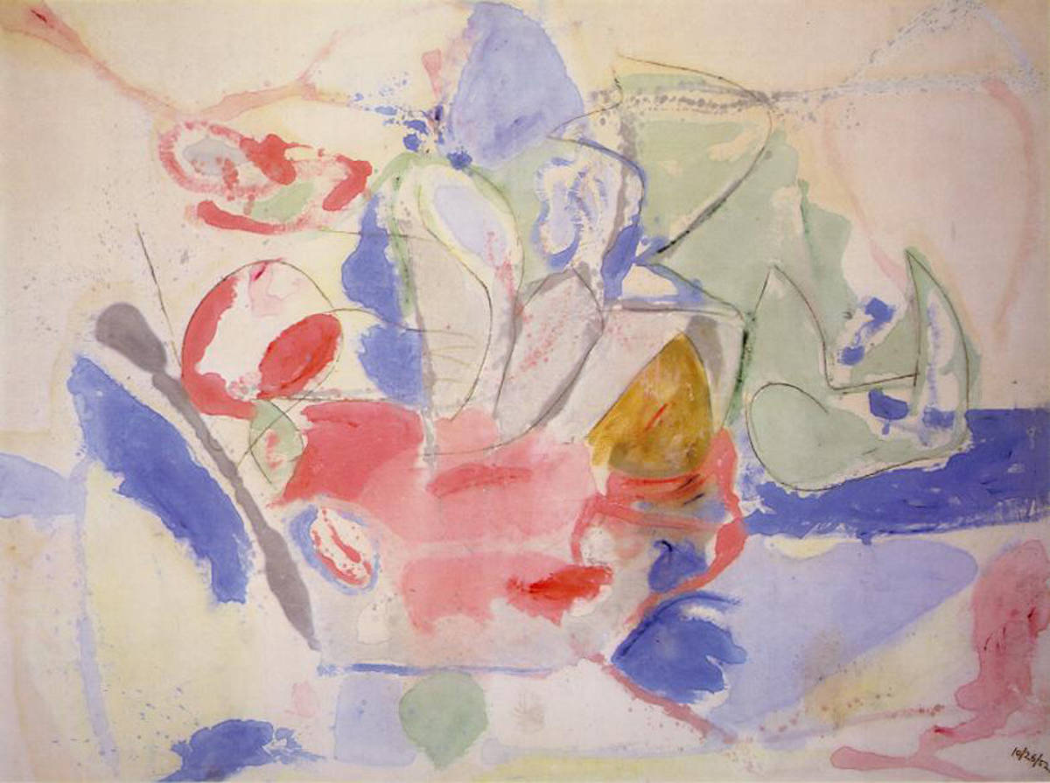

*Mountains and Sea,* 1952, 86 5/8 x 117 1/4 inches, (220 x 297.8 cm., oil and charcoal on canvas, on extended loan to the [National Gallery of Art](http://en.wikipedia.org/wiki/National_Gallery_of_Art), [Washington, DC.](http://en.wikipedia.org/wiki/Washington,_DC.)

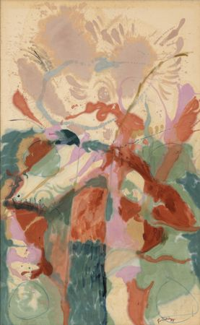

*Jacob’s Ladder,* 1957, Oil on canvas (9*'* 5 3/8" x 69 7/8" (287.9 x 177.5 cm))

Museum of Modern Art, New York. <http://www.moma.org/collection/object.php?object_id=78722>